SIMATS ENGINEERING
ASSESSMENT TOOL 1: Experiments
COURSE NAME: COMPUTER VISION COURSE CODE:ITA0515 Slot

COURSE OUTCOME COVERED
CO3: Analyze and extract image features using detection and matching techniques for effective image representation and comparison. (BTL 4) Assessment Tool Weightage: 40%

QUESTIONS:3 Total Marks 30 Duration :60 Minutes
Criteria | Weightage (%) | Level 4 (Exemplary) | Level 3  (Proficient) | Level 2  (Developing) | Level 1  (Beginning) | Marks(100  )
Understanding of Concepts | 25 | Demonstrates thorough understanding and effectively integrates multiple  concepts/technologies | Good understanding with proper integration of most concepts | Basic understanding; limited or partial integration | Poor understanding; unable to integrate concepts
Experimental Design | 30 | Well-planned, systematic implementation with optimal solution | Correct implementation with minor issues | Basic implementation with errors or inefficiencies | Incorrect or incomplete implementation
Use of Tools | 20 | Effective and advanced use of tools/technologies with proper configuration | Appropriate use of tools with correct execution | Limited or inconsistent use of tools | Incorrect or minimal use of tools
Analysis of Results | 15 | Insightful analysis with accurate interpretation and validation of results | Good analysis with reasonable interpretation | Basic analysis with limited insights | Poor or incorrect analysis of results
Documentation | 10 | Clear, well-structured documentation with diagrams, code, and results | Organized documentation with necessary details | Basic documentation with missing details | Poor or incomplete documentation
Annexure A Experiments

Code of Conduct:
I K.Mounith(192425090) certify that this submission is my original work and that I have adhered to the guidelines specified for this assessment.
I understand that any violation of academic integrity rules will result in disciplinary action.
Signature of the student:K.Mounith
Rubrics for Evaluation
- Harris Corner Detection Analysis
Perform Harris corner detection on images containing varying textures and patterns. Explain the concept of corner detection and its importance in computer vision tasks. Use appropriate parameters and tools to execute the experiment, document the detected corner points clearly, and analyze the distribution, accuracy, and significance of the detected corners.
A.import cv2
import numpy as np
import matplotlib.pyplot as plt
from tkinter import Tk, filedialog

# ---------------------------------------------------------
# Harris Corner Detection
# ---------------------------------------------------------

# Hide the main Tkinter window
root = Tk()
root.withdraw()

# Select an image
file_path = filedialog.askopenfilename(
title="Select an Image",
filetypes=[
("Image Files", "*.jpg *.jpeg *.png *.bmp")
]
)

# Check whether an image was selected
if not file_path:
print("No image selected.")
exit()

# Read image
image = cv2.imread(file_path)

if image is None:
print("Error: Could not load the selected image.")
exit()

# Convert BGR to RGB
image_rgb = cv2.cvtColor(image, cv2.COLOR_BGR2RGB)

# Convert to grayscale
gray = cv2.cvtColor(image, cv2.COLOR_BGR2GRAY)

# Convert image to float32
gray_float = np.float32(gray)

# Harris Corner Detection
dst = cv2.cornerHarris(
gray_float,
blockSize=2,
ksize=3,
k=0.04
)

# Dilate corner points
dst = cv2.dilate(dst, None)

# Set threshold
threshold = 0.01 * dst.max()

# Copy original image
result = image_rgb.copy()

# Mark corners in red
result[dst > threshold] = [255, 0, 0]

# Count corners
corner_count = np.sum(dst > threshold)

# Display information
print("--------------------------------------")
print("HARRIS CORNER DETECTION ANALYSIS")
print("--------------------------------------")
print("Selected Image:", file_path)
print("Number of detected corners:", corner_count)
print("--------------------------------------")

# Display images
plt.figure(figsize=(12, 5))

plt.subplot(1, 2, 1)
plt.imshow(image_rgb)
plt.title("Original Image")
plt.axis("off")

plt.subplot(1, 2, 2)
plt.imshow(result)
plt.title("Harris Corner Detection")
plt.axis("off")
plt.tight_layout()
plt.show()

OUTPUT;
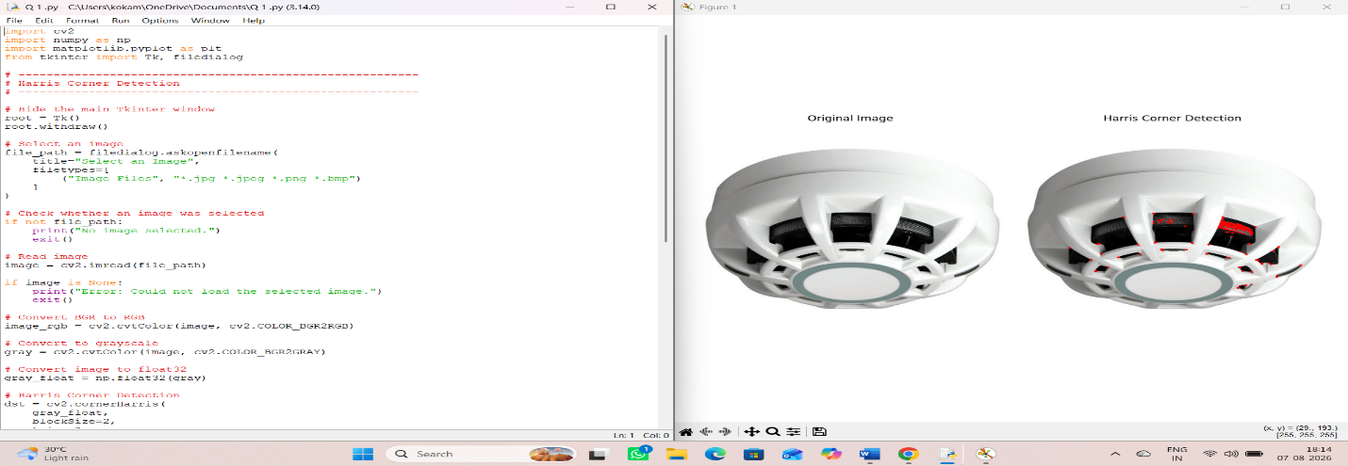
- Effect of Noise on Corner Detection
Design an experiment to study the effect of noise on Harris corner detection performance. Explain the purpose of introducing noise and its influence on image features. Add noise systematically, perform corner detection using suitable tools, document observations for original and noisy images, and analyze the impact of noise along with possible improvement techniques.
A.import cv2
import numpy as np
import matplotlib.pyplot as plt
from tkinter import Tk, filedialog
# ---------------------------------------------------------
# EXPERIMENT 2
# Effect of Noise on Harris Corner Detection
# ---------------------------------------------------------
# Open file selection window
root = Tk()
root.withdraw()
file_path = filedialog.askopenfilename(
title="Select an Image",
filetypes=[
("Image Files", "*.jpg *.jpeg *.png *.bmp")
]
)
# Check image selection
if not file_path:
print("No image selected.")
exit()
# Read image
image = cv2.imread(file_path)
if image is None:
print("Error: Image could not be loaded.")
exit()
# Convert BGR to RGB
image_rgb = cv2.cvtColor(image, cv2.COLOR_BGR2RGB)
# Convert image to grayscale
gray = cv2.cvtColor(image, cv2.COLOR_BGR2GRAY)
# ---------------------------------------------------------
# Function to Add Gaussian Noise
# ---------------------------------------------------------
def add_gaussian_noise(image, noise_level):
# Generate Gaussian noise
noise = np.random.normal(
0,
noise_level,
image.shape
)
# Add noise
noisy_image = image.astype(np.float32) + noise
# Keep pixel values between 0 and 255
noisy_image = np.clip(noisy_image, 0, 255)
return noisy_image.astype(np.uint8)
# ---------------------------------------------------------
# Function for Harris Corner Detection
# ---------------------------------------------------------
def detect_corners(image):
# Convert to grayscale
gray = cv2.cvtColor(image, cv2.COLOR_RGB2GRAY)
# Convert to float32
gray = np.float32(gray)
# Harris Corner Detection
corners = cv2.cornerHarris(
gray,
blockSize=2,
ksize=3,
k=0.04
)
# Dilate corner response
corners = cv2.dilate(corners, None)
# Threshold
threshold = 0.01 * corners.max()
# Copy image
result = image.copy()
# Mark detected corners in red
result[corners > threshold] = [255, 0, 0]
# Count corners
count = np.sum(corners > threshold)
return result, count
# ---------------------------------------------------------
# Generate Noisy Images
# ---------------------------------------------------------
np.random.seed(42)
noisy_low = add_gaussian_noise(image_rgb, 10)
noisy_medium = add_gaussian_noise(image_rgb, 25)
noisy_high = add_gaussian_noise(image_rgb, 50)
# ---------------------------------------------------------
# Harris Corner Detection
# ---------------------------------------------------------
result_original, count_original = detect_corners(image_rgb)
result_low, count_low = detect_corners(noisy_low)
result_medium, count_medium = detect_corners(noisy_medium)
result_high, count_high = detect_corners(noisy_high)
# ---------------------------------------------------------
# Print Results
# ---------------------------------------------------------
print("\n==============================================")
print(" EFFECT OF NOISE ON HARRIS CORNER DETECTION")
print("==============================================")
print("Image:", file_path)
print("\nDetected Corner Points:")
print("----------------------------------------------")
print("Original Image :", count_original)
print("Low Noise :", count_low)
print("Medium Noise :", count_medium)
print("High Noise :", count_high)
print("----------------------------------------------")
# ---------------------------------------------------------
# Display Results
# ---------------------------------------------------------
plt.figure(figsize=(15, 10))
# Original
plt.subplot(2, 4, 1)
plt.imshow(image_rgb)
plt.title("Original Image")
plt.axis("off")
plt.subplot(2, 4, 5)
plt.imshow(result_original)
plt.title("Original - Corners")
plt.axis("off")
# Low Noise
plt.subplot(2, 4, 2)
plt.imshow(noisy_low)
plt.title("Low Noise")
plt.axis("off")
plt.subplot(2, 4, 6)
plt.imshow(result_low)
plt.title("Low Noise - Corners")
plt.axis("off")
# Medium Noise
plt.subplot(2, 4, 3)
plt.imshow(noisy_medium)
plt.title("Medium Noise")
plt.axis("off")
plt.subplot(2, 4, 7)
plt.imshow(result_medium)
plt.title("Medium Noise - Corners")
plt.axis("off")
# High Noise
plt.subplot(2, 4, 4)
plt.imshow(noisy_high)
plt.title("High Noise")
plt.axis("off")
plt.subplot(2, 4, 8)
plt.imshow(result_high)
plt.title("High Noise - Corners")
plt.axis("off")
plt.tight_layout()
plt.show()
# ---------------------------------------------------------
# Noise Reduction Using Gaussian Blur
# ---------------------------------------------------------
# Apply Gaussian filtering to high-noise image
filtered_image = cv2.GaussianBlur(
noisy_high,
(5, 5),
0
)
# Detect corners after noise reduction
filtered_result, filtered_count = detect_corners(
filtered_image
)
print("\nAfter Gaussian Noise Reduction:")
print("Corners detected:", filtered_count)
# ---------------------------------------------------------
# Display Noise Reduction Result
# ---------------------------------------------------------
plt.figure(figsize=(12, 5))
plt.subplot(1, 2, 1)
plt.imshow(noisy_high)
plt.title("High Noise Image")
plt.axis("off")
plt.subplot(1, 2, 2)
plt.imshow(filtered_result)
plt.title("After Gaussian Filtering - Corners")
plt.axis("off")
plt.tight_layout()
plt.show()
# ---------------------------------------------------------
# Graph: Noise Level vs Number of Corners
# ---------------------------------------------------------
noise_levels = [0, 10, 25, 50]
corner_counts = [
count_original,
count_low,
count_medium,
count_high
]
plt.figure(figsize=(8, 5))
plt.plot(
noise_levels,
corner_counts,
marker="o"
)
plt.xlabel("Noise Level")
plt.ylabel("Number of Detected Corners")
plt.title("Effect of Noise on Harris Corner Detection")
plt.grid(True)
plt.show()
OUTPUT;
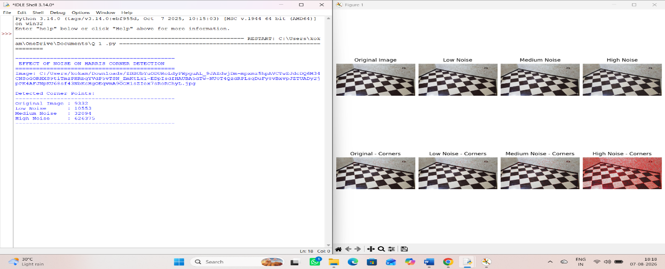
- Hough Transform for Shape Detection
Conduct an experiment using the Hough Transform to detect lines or circles in an image. Explain the principles and significance of the Hough Transform in shape detection. Execute the detection process using appropriate tools, record the detected shapes and their parameters, and analyze the detection accuracy under different image conditions.
A.import cv2
import numpy as np
import matplotlib.pyplot as plt
from tkinter import Tk, filedialog

# ---------------------------------------------------------
# EXPERIMENT 3
# HOUGH TRANSFORM FOR SHAPE DETECTION
# ---------------------------------------------------------

# Open file selection window
root = Tk()
root.withdraw()

file_path = filedialog.askopenfilename(
title="Select an Image",
filetypes=[
("Image Files", "*.jpg *.jpeg *.png *.bmp")
]
)

# Check image selection
if not file_path:
print("No image selected.")
exit()

# Read image
image = cv2.imread(file_path)

if image is None:
print("Error: Could not load image.")
exit()

# Convert BGR to RGB
image_rgb = cv2.cvtColor(image, cv2.COLOR_BGR2RGB)

# Convert to grayscale
gray = cv2.cvtColor(image, cv2.COLOR_BGR2GRAY)

# Smooth image to reduce noise
gray_blur = cv2.GaussianBlur(gray, (5, 5), 0)

# =========================================================
# 1. HOUGH LINE TRANSFORM
# =========================================================

# Detect edges using Canny
edges = cv2.Canny(
gray_blur,
50,
150,
apertureSize=3
)

# Detect lines
lines = cv2.HoughLinesP(
edges,
rho=1,
theta=np.pi / 180,
threshold=80,
minLineLength=50,
maxLineGap=10
)

# Copy image for drawing lines
line_result = image_rgb.copy()

line_count = 0

if lines is not None:

for line in lines:

x1, y1, x2, y2 = line[0]

# Draw detected line
cv2.line(
line_result,
(x1, y1),
(x2, y2),
(255, 0, 0),
3
)

line_count += 1

# =========================================================
# 2. HOUGH CIRCLE TRANSFORM
# =========================================================

circles = cv2.HoughCircles(
gray_blur,
cv2.HOUGH_GRADIENT,
dp=1.2,
minDist=30,
param1=100,
param2=30,
minRadius=10,
maxRadius=200
)

# Copy image for drawing circles
circle_result = image_rgb.copy()

circle_count = 0

if circles is not None:

circles = np.uint16(
np.around(circles)
)

for circle in circles[0, :]:

x, y, r = circle

# Draw circle
cv2.circle(
circle_result,
(x, y),
r,
(0, 255, 0),
3
)

# Draw center
cv2.circle(
circle_result,
(x, y),
3,
(255, 0, 0),
-1
)

circle_count += 1

# =========================================================
# DISPLAY RESULTS
# =========================================================

print("\n==============================================")
print(" HOUGH TRANSFORM FOR SHAPE DETECTION")
print("==============================================")

print("\nImage:", file_path)

print("\nDetected Shapes")
print("----------------------------------------------")
print("Number of Lines :", line_count)
print("Number of Circles :", circle_count)
print("----------------------------------------------")

# Display results
plt.figure(figsize=(15, 10))
# Original image
plt.subplot(2, 2, 1)
plt.imshow(image_rgb)
plt.title("Original Image")
plt.axis("off")
# Edge image
plt.subplot(2, 2, 2)
plt.imshow(edges, cmap="gray")
plt.title("Canny Edge Detection")
plt.axis("off")
# Lines
plt.subplot(2, 2, 3)
plt.imshow(line_result)
plt.title("Hough Line Detection")
plt.axis("off")
# Circles
plt.subplot(2, 2, 4)
plt.imshow(circle_result)
plt.title("Hough Circle Detection")
plt.axis("off")

plt.tight_layout()
plt.show()

print("\nLINE PARAMETERS")
print("----------------------------------------------")
if lines is not None:
for i, line in enumerate(lines):
x1, y1, x2, y2 = line[0]
# Calculate length
length = np.sqrt(
(x2 - x1) ** 2 +
(y2 - y1) ** 2
)
# Calculate angle
angle = np.degrees(
np.arctan2(
y2 - y1,
x2 - x1
)
)
print(
f"Line {i + 1}: "
f"({x1},{y1}) -> ({x2},{y2}), "
f"Length = {length:.2f}, "
f"Angle = {angle:.2f} degrees"
)
else:
print("No lines detected.")
# =========================================================
# PRINT CIRCLE PARAMETERS
# =========================================================
print("\nCIRCLE PARAMETERS")
print("----------------------------------------------")
if circles is not None:
for i, circle in enumerate(circles[0, :]):
x, y, r = circle
print(
f"Circle {i + 1}: "
f"Center = ({x},{y}), "
f"Radius = {r}"
)
else:
print("No circles detected.")
print("\n==============================================")
print("Experiment completed successfully.")
print("==============================================")
OUTPUT;
